WEEK 3 -
PROCESS SCHEDULING SIMULATOR

1. Objective
To design and implement a CPU Scheduling Simulator in C that executes processes using six scheduling algorithms, displays their execution through Gantt charts, calculates performance metrics, and compares the results to understand the efficiency of each algorithm.

2. Introduction
CPU scheduling is an important function of an operating system that decides which process gets the CPU. Different algorithms use arrival time, burst time, priority, or time quantum to schedule processes.
This project implements a menu-driven CPU Scheduling Simulator in C that displays Gantt charts and calculates performance metrics for different scheduling algorithms.

3. Input Specification
The simulator accepts the following inputs for each process:
- Process ID (PID): Unique identifier of the process.
- Arrival Time (AT): Time when the process arrives.
- Burst Time (BT): CPU time required by the process.
- Priority: Priority assigned to the process.

4 . TEST CASE 1
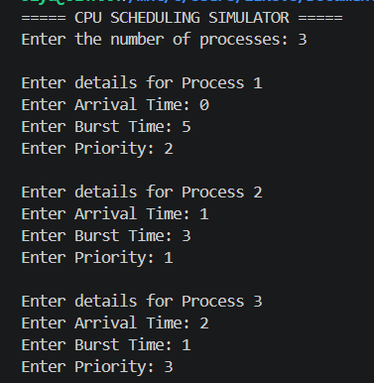

4.1 FCFS
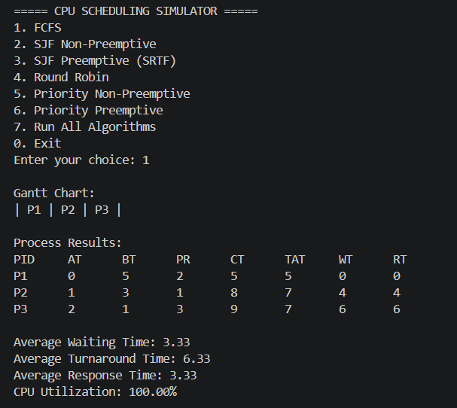
4.2 SJF Non-Preemptive
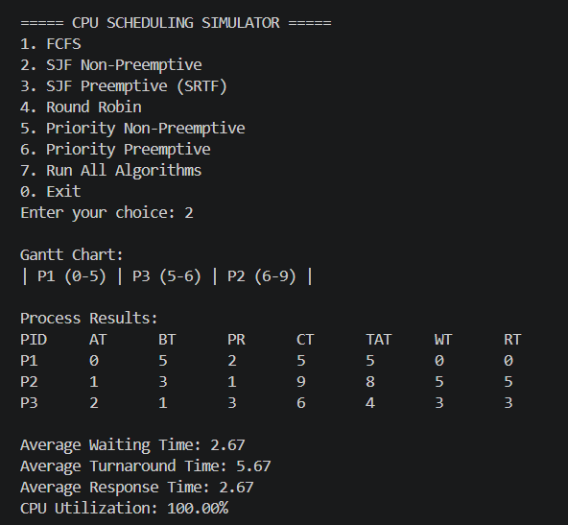
4.3 SJF Preemptive (SRTF)
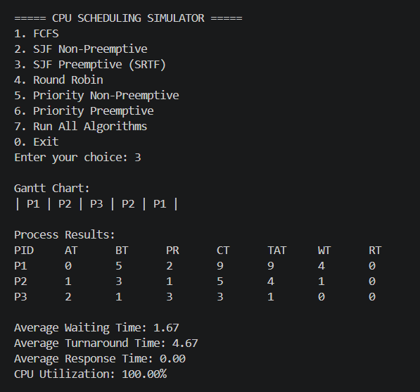

4.4 Round Robin
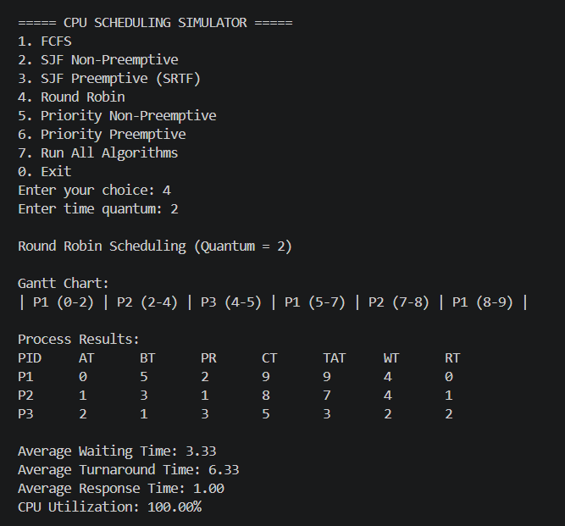
4.5 Priority Non-Preemptive
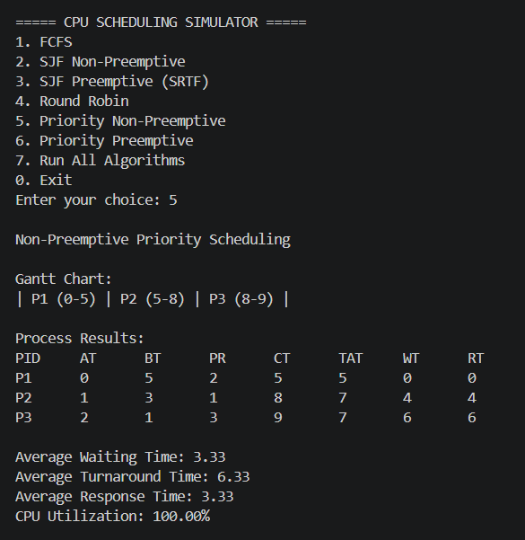
4.6 Priority Preemptive
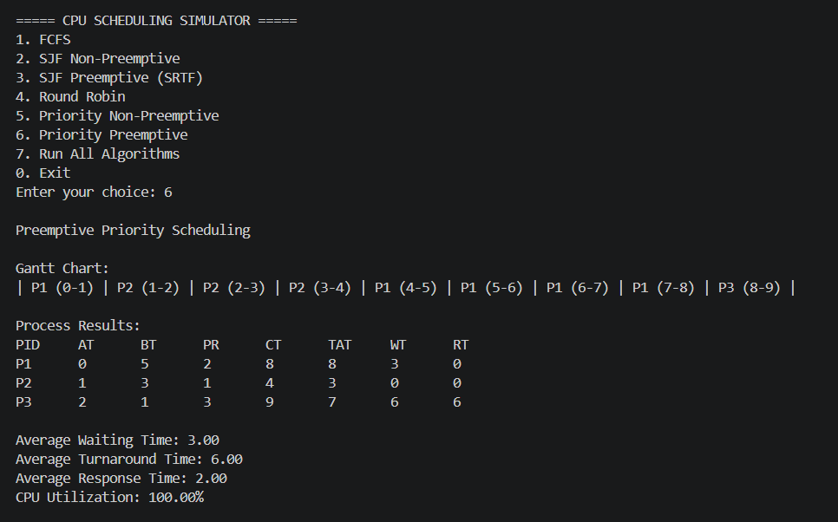

5. TEST CASE 2
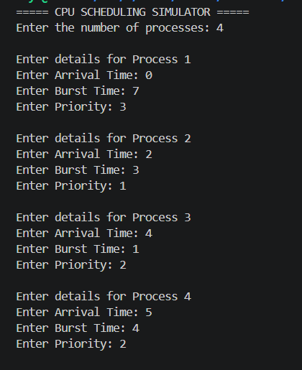
5.1 FCFS
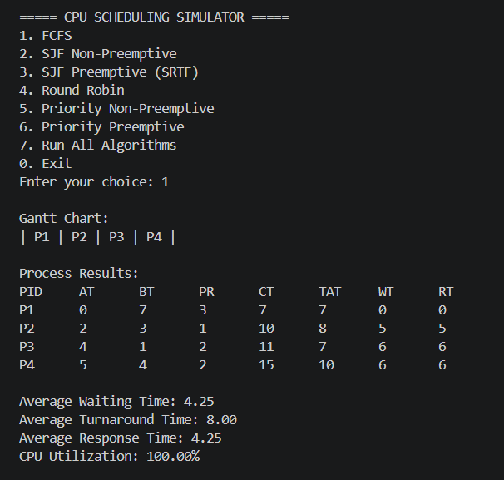
5.2 SJF Non-Preemptive
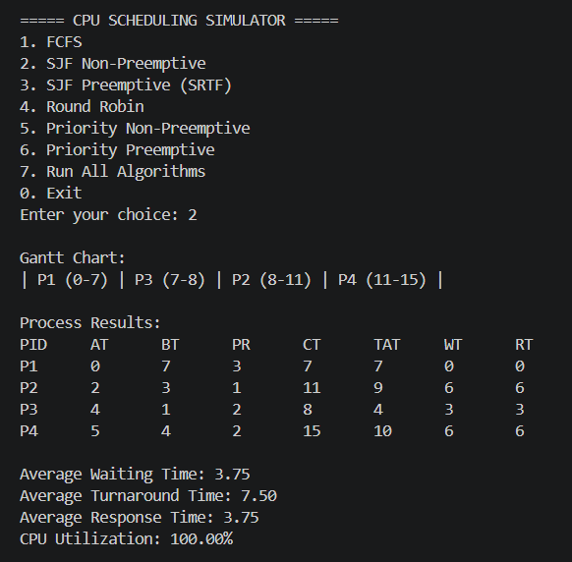
5.3 SJF Preemptive (SRTF)
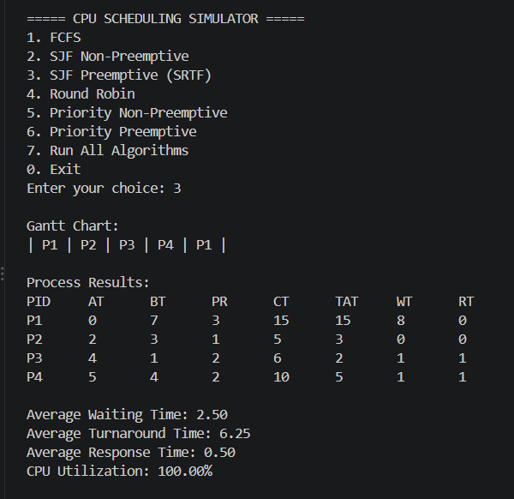
5.4 Round Robin
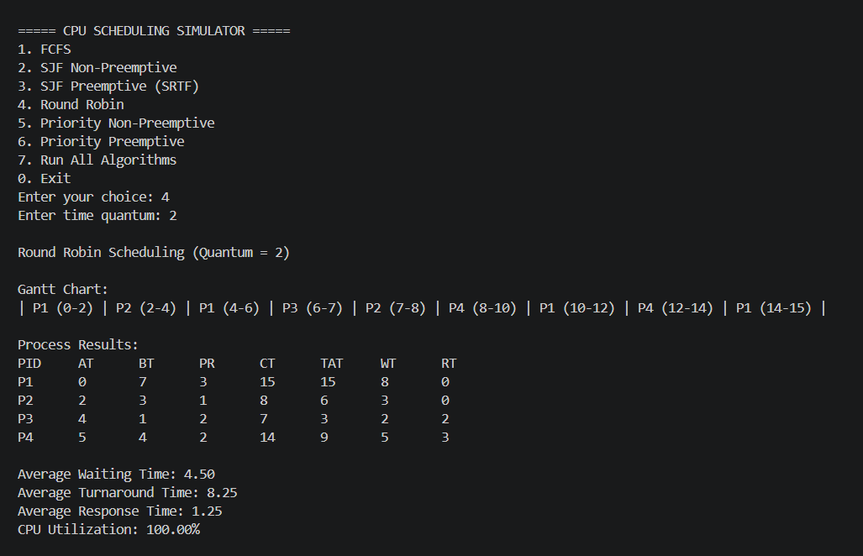
5.5 Priority Non-Preemptive
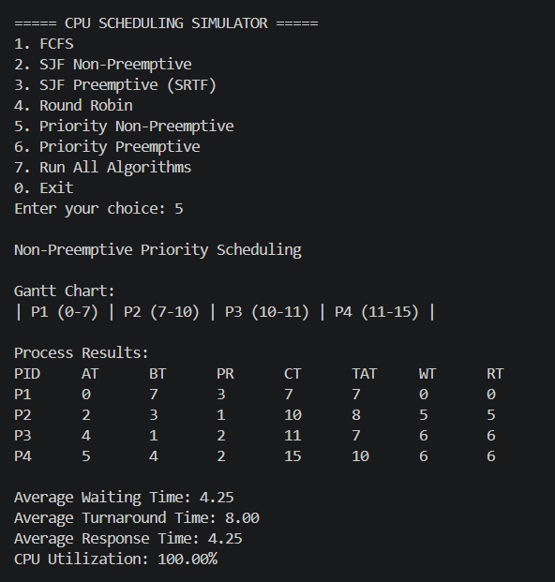
5.6 Priority Preemptive
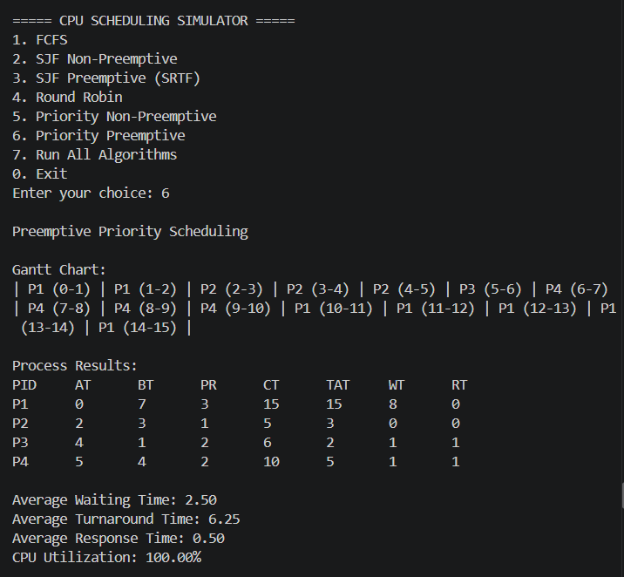
6. TEST CASE 3
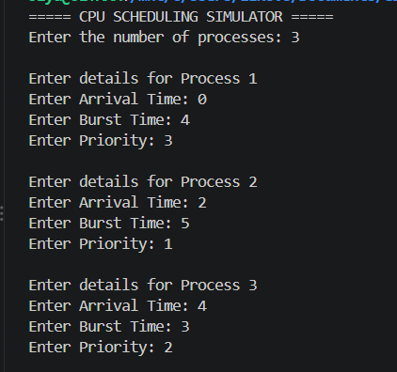
6.1 FCFS
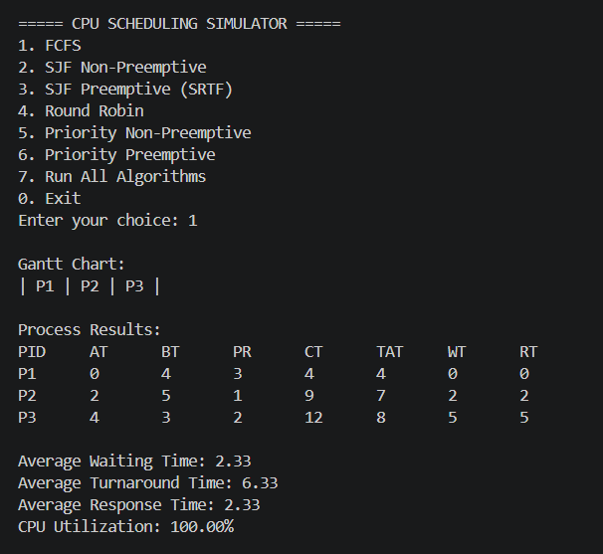
6.2 SJF Non-Preemptive
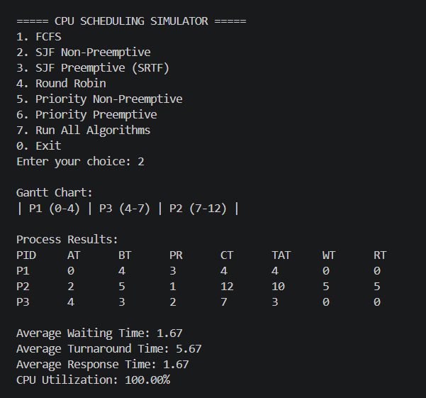
6.3 SJF Preemptive (SRTF)
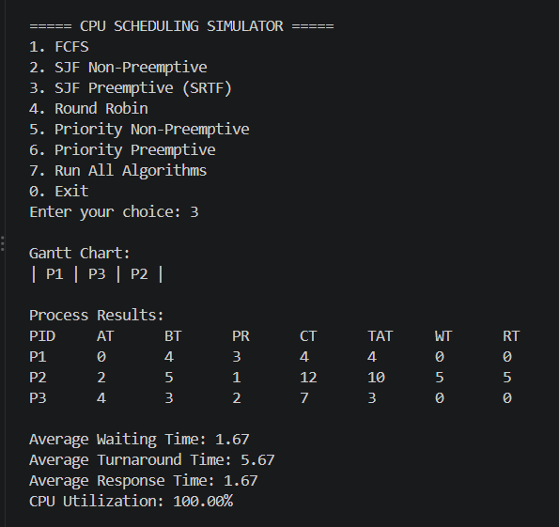
6.4 Round Robin
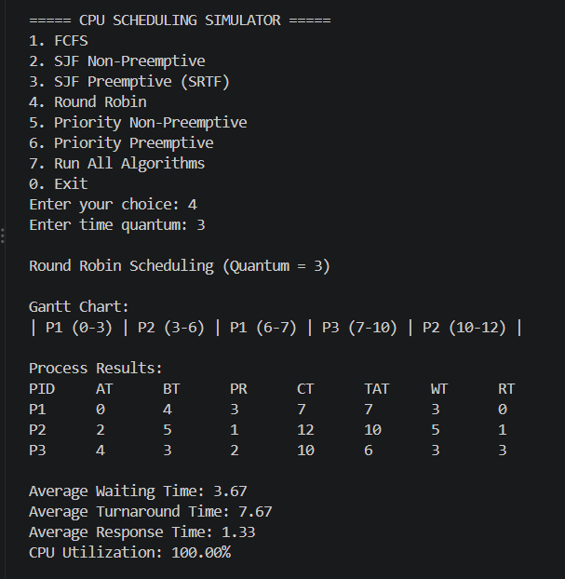
6.5 Priority Non-Preemptive
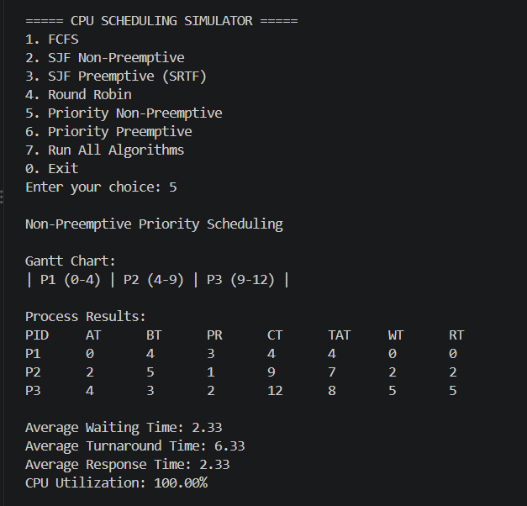
6.6 Priority Preemptive
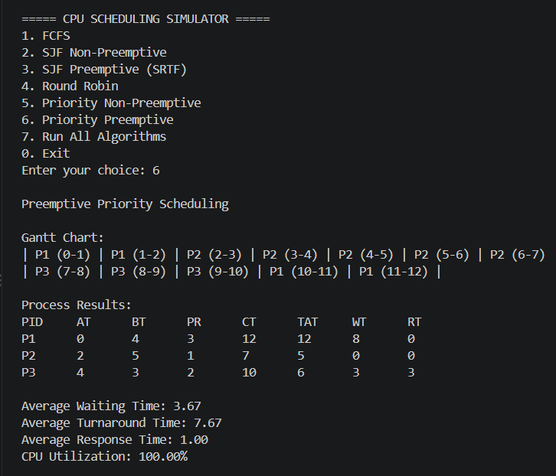

7. PERFORMANCE COMPARISION

The six CPU scheduling algorithms are compared using Average Waiting Time, Average Turnaround Time, Average Response Time, and CPU Utilization. The results from three test cases help identify the differences in performance and efficiency of each algorithm.

TEST CASE 1
Algorithm | Average WT | Average TAT | Average RT | CPU Utilization
FCFS | 3.33 | 6.33 | 3.33 | 100%
SJF Non-Preemptive | 2.67 | 5.67 | 2.67 | 100%
SRTF | 1.67 | 4.67 | 0.00 | 100%
Priority Non-Preemptive | 3.33 | 6.33 | 3.33 | 100%
Priority Preemptive | 3.00 | 6.00 | 2.00 | 100%
Round Robin | 3.33 | 6.33 | 1.00 | 100%

TEST CASE 2
Algorithm | Average WT | Average TAT | Average RT | CPU Utilization
FCFS | 3.25 | 7.00 | 3.25 | 100%
SJF Non-Preemptive | 2.75 | 6.50 | 2.75 | 100%
SRTF | 1.75 | 5.50 | 0.25 | 100%
Priority Non-Preemptive | 3.25 | 7.00 | 3.25 | 100%
Priority Preemptive | 1.75 | 5.50 | 0.25 | 100%
Round Robin | 2.75 | 6.50 | 0.75 | 100%

TEST CASE 3
Algorithm | Average WT | Average TAT | Average RT | CPU Utilization
FCFS | 2.00 | 6.00 | 2.00 | 100%
SJF Non-Preemptive | 2.00 | 6.00 | 2.00 | 100%
SRTF | 1.33 | 5.33 | 0.00 | 100%
Priority Non-Preemptive | 2.00 | 6.00 | 2.00 | 100%
Priority Preemptive | 1.33 | 5.33 | 0.00 | 100%
Round Robin | 2.33 | 6.33 | 1.33 | 100%

8. PERFORMANCE ANALYSIS
The CPU scheduling simulator was tested using three test cases with different arrival times, burst times, and priority values. Round Robin was tested using different time quantum values.
- FCFS: Executes processes in the order they arrive. It is simple but may cause longer waiting times.
- SJF Non-Preemptive: Selects the process with the shortest burst time among the available processes. It can reduce average waiting time.
- SJF Preemptive (SRTF): Selects the process with the shortest remaining execution time. It can provide lower waiting and response times.
- Priority Non-Preemptive: Executes the available process with the highest priority and continues until it finishes.
- Priority Preemptive: Allows a higher-priority process to interrupt a running process when required.
- Round Robin: Gives each process a fixed time quantum. It provides a fair opportunity for processes to execute.
The results show that different scheduling algorithms perform differently depending on process arrival times, burst times, priorities, and the Round Robin time quantum. Average Waiting Time, Average Turnaround Time, Average Response Time, and CPU Utilization help compare their performance.
CPU utilization was 100% in the updated test cases because the CPU had processes available throughout the execution period. The comparison tables help identify which algorithms perform better for each set of inputs.

9. CONCLUSION
The CPU Scheduling Simulator was developed using the C programming language to demonstrate six CPU scheduling algorithms: FCFS, SJF Non-Preemptive, SJF Preemptive, Priority Non-Preemptive, Priority Preemptive, and Round Robin.
The simulator accepts process details such as Process ID, Arrival Time, Burst Time, and Priority. It displays scheduling results and Gantt charts and calculates important performance metrics, including Waiting Time, Turnaround Time, Response Time, and CPU Utilization.
Testing with three different test cases helped us understand how each algorithm schedules processes and affects system performance. The comparison tables made it easier to study the differences between the algorithms.
Overall, this project improved our understanding of CPU scheduling, process execution, performance measurement, teamwork, and integration of different modules into one working program.

